Orbital Shaker—MPS-10
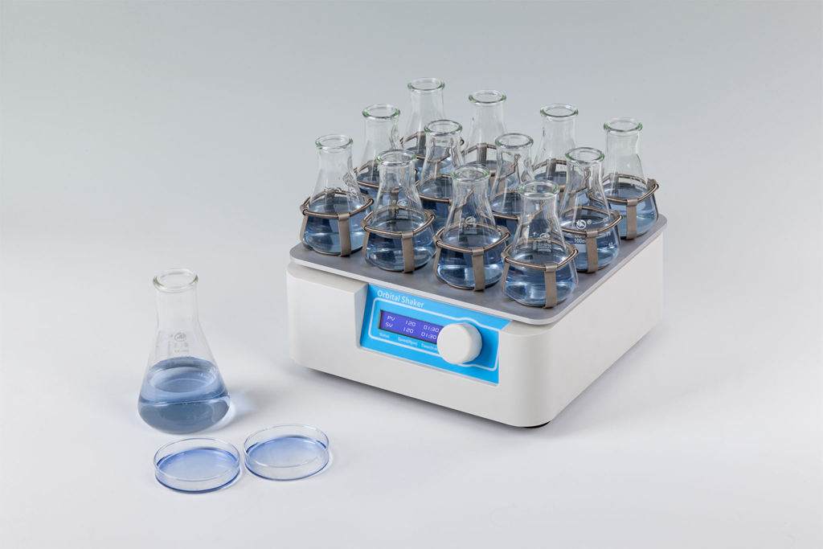
Description:
MPS-10 Orbital Shaker is a high speed shaker with direct brushless DC motor and microprocessor controlled technique. It can be applicable in different laboratories: in microbiology, biotechnology, medical analysis, etc.

Features:
- LCD displays time and shaking speed.
- Easy to operate with one-touch knob.
- Warm root and variety of platforms can be chosen.
- When time control ends, instrument will make alarm voice.
- Gentle and reliable shaking with direct brushless DC motor.

Parameters:
Type  Parameter | MPS-10
Time range | 1min ~ 99h59min
Speed range | 50～300rpm
Orbit | 10mm
Capacity(PP-1 tray) | 8pcs petri dishes
Capacity(PP-2 tray) | 6×100ml or 4×250ml conical flask
Capacity(PP-3 tray) | 12×100ml or 6×250ml conical flask
Power | 50W
Voltage | AC100V~240V 50/60Hz
Dimension(mm) | 280×270×110
Weight(kg) | 7.0

